The Design, Development, and Implementation of Fabry-Perot Interferometer

A SENIOR PROJECT SUBMITTED TO THE

DEPARTMENT OF ELECTRICAL ENGINEERING & RENEWABLE ENERGY

OF THE SCHOOL OF ENGINEERING, TECHNOLOGY, AND MANAGEMENT AT THE

OREGON INSTITUTE OF TECHNOLOGY

IN PARTIAL FULFILLMENT OF THE REQUIREMENTS FOR THE

DEGREE OF BACHELOR OF SCIENCE

David Miles Houston

© January 2015

Senior Project Approval Page

THE SENIOR PROJECT OF **DAVID M HOUSTON** FOR THE BACHELOR OF SCIENCE

DEGREE WAS ACCEPTED BY THE EVALUATION COMMITTEE AND THE

DEPARTMENT OF ELECTRICAL ENGINEERING AT THE OREGON INSTITUTE OF

TECHNOLOGY

ACADEMIC SENIOR PROJECT ADVISOR APPROVAL:

_________________________________________________

DR. SCOTT PRAHL, PH.D.

THE FOLLOWING PAPER PRESENTS A CONCISE DESCRIPTION OF THE SENIOR PROJECT FOLLOWING THE IEEE JOURNAL GUIDELINES. THIS ABBREVIATED REPORT EXCLUDES ALL CONFIDENTIAL INFORMATION AND IT IS THEREFORE ADEQUATE FOR PUBLIC DISSEMINATION

|  |  |
| --- | --- |
| **A Fabry-Perot Interferometer with**  **Serial-GUI Data Analysis and Oscilloscope Compatibility**  David Houston  ***Abstract*— I describe a lost cost form of designing a fabry-perot interferometer with its constituent driver and interfacing it with a GUI in order to manage it with a serial connection (i.e. usb or bluetooth)**  **Index Terms—Interferometer, Serial, Graphical User Interface (GUI), Scanning Fabry-Perot Interferometer (FPSI)**   1. INTRODUCTION   The light amplification by stimulated emission of radiation, or more formally know as the Laser. Laser’s are a thing of the future, or so they were back in the 1930’s, and on the fringe of science today. While the applications of lasers are vast and exciting, laser, just as much as anything else, need to be understood and explained by models and graphs and spectrums. The FPSI just does that by displaying the different associated modes of the laser as a frequency spectrum.   1. RECORDER DESCRIPTION   This section describes the explicit design assumptions with respect to the specified components and overall cohesiveness of the different sections. Fig. 1 displays the block diagram of interaction between devices.   * 1. *FPSI*   The scanning fabry-perote interferometer uses two confocal reflective mirrors which, by stimulation of a ramp function at a “changeable frequency” a piezo is attached to one, creating the different sperabaly distinguishable modes of the laser.[1]. Fig. 2A displays the layout of the FPSI. The mirrors that will be used for the FPSI are such that they are not “perfect” (i.e. they do not have total specular reflection) so they allow some light to pass through, that way the output of the system can be measured by a photodiode of sorts. In order to determine the setup and subsequently the behavior of the system, the focal length of the mirrors needed to be determined. Fig. 2B displays the setup for measuring the focal length of the concave mirriors. After taking a substantial amount of data from different time it was determined that the focal length was $F_{total}=20.2±0.2 mm$. The data can be viewed in Table 1A in Appendix A.   * 1. *Interferometer Driver*   The driver will be constructed using an arduino microcontroller. The arduino will take in a set of analog signal values in order to control the output (i.e. the ramp wave). These analog signals will be converted into digital signals and analyzed by the microcontroller and then sent to the arduino. The set of 10-bit values will be averaged every clock-cycle. These values will correspond to writeable values, which the 8-bit microcontroller will use to generate the relatively standardized saw-tooth ramp function as shown in Fig. 3. This wave will have a minimum bit resolution of 19.5 mV/bit given the specifications of the microcontroller outputting a signal with a max voltage of 5V. Because of this bit resolution the minimum voltage will have to be defined based on the number of pulses that is adequate to produce a ramp function.  By using MATLAB it was confirmed that a bit-width of at least 20 individual values, having a maximum binary storage value of 10100, must occur in order to create a functioning ramp signal with limited distortion. This means that the microcontroller will only be able to produce a minimum voltage of 390mV. Attenuating the voltage with a potentiometer can reduce the minimum voltage. This will adjust the voltage within a relatively small range, while the input signal to the micro controller will generate the bit resolution and max amplitude output.  The frequency will be controlled by the value from the analog input and will only change the amount of time the signal is on. The signal has an off, or rest time, which stays constant regardless of the frequency. Fig. 4 describes the layout of the first part of this system. The output which consists of a digitally-synthesized analog saw-tooth signal which will be fed to an amplifier to boost the “horizontal signal” up to a maximum of 16 V and a minimum of 62.4 mV. Both of these forms of control can be overridden by using the I2C interface by plugging the usb into the into the arduino uno and using a interactive GUI which will be discussed later thourghout this paper. However, the ADC microcontroller will have 16-bit resolution with an I2C interface. The specs for the ADS1115 microcontroller are in Appendix B.  The original driver had a range from 3.7mV to 16V, however, such a low voltage provides no advantage to the system. This is due the horizontal sweeping which is “designed to be proportional to the change in frequency of the interferometer transmission peaks.”[2] Fig. 5 shows the process by which the signal is processed. The saw-tooth will then be sent though a high power amplifier in order to boost it up to a max voltage of either 300 or 1kV. This will allow the driver to power the FPSI. | However, before the signal is sent to the power amplifier it will need to be sent through an attenuator to control the length in voltage (and in frequency) the scan will go [2]. This will consist of an assortment of resistors in parallel of different magnitudes, which will be switched too, and a series varistor to make small changes in the attenuation.  In order to control what section of the frequency spectrum to view, a controllable DC offset will be added to the driving signal before the power amplifier and it will be modulated via a variable resistor or some other form of attenuating the signal.   * 1. *Photo-detector*   The photo-detector will be mounted to an adjustable plate at the rear of the FPSI so as to allow for calibration of the FPSI. This will allow for maximum collection of the the FPSI output and a better spectral reading on the output if the device is secure and stable. The output from the photo-detector will have to be amplified due to its small output signal. The amplitude output of a typical photo-detector is around 50mV. Based on the first design, it would be reasonable to assume that we would need an amplifier setup capable of producing an Closed-loop amplification of 10^4. This will be created by a variety of OpAmps and magnitude resistors in order to maximize amplification in the system with a “tuning” resistor to focus on certain magnitudes of output.   1. *Output to Oscilloscope*   The connection that allows the connection will have to “type of connection” in order that they oscilloscope can take in the output from the photo-detector and the ramp function generated by the microcontroller so that it can perform an X-Y plot of the output and from there extrapolate the data in the frequency spectrum.   * + 1. *ADC Output*   The output from the amplification of the photo-detector will be fed to an ADC. This will be digitized and serialized by the ADC into a 10-bit output with an I2C interface. The interface will got to a switchable output which be the master would be either a computer or a small device. The switchable output would switch between USB, Bluetooth, and Wifi for the serial data transfer between the master and the slave devices.   * + 1. *Graphical User Interface*   The GUI will take in the data from the ADC, which will be acquired via serial I2C configuration. The data will mathematically manipulated so as to create a frequency spectrum of the output. This in turn will be graphed as displayed as output. The data values will be updated based on the clock cycle set by the master device. These values will be updated and stored in a csv file so as to compare later .   1. DISCUSSION   The discussion on this topic is quite interesting and will be left for a later time.   1. IMPROVEMENT   In order to improve the device would be to create all of the attenuators and input signals into digitally controlled values and route the output  REFRENCES:  [1] Hercher, M. (1987) *The Spherical Mirror Fabry-Perot Interferomter.* Applied Optics 7,  No 5: 951-966  [2] Spectra Physics (1965) Model 476 Scanning Interferometer Driver. |
|  |  |

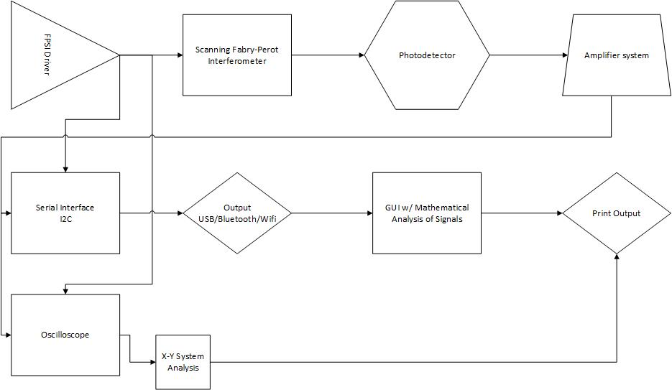

Figure 1 – Block Diagram of Setup

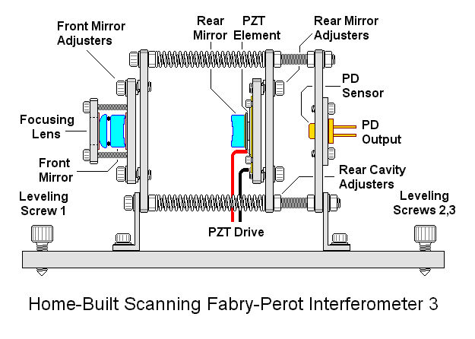

Figure 2A – Design of a similar FPSI (Place holder until I make a design in CAD or some sort of designing software)

Figure 2B – Setup for measureing the radius of curvature of the concave mirrors

Appendix A

|  |  |  |  |
| --- | --- | --- | --- |
|  |  |  |  |
|  | **Radius of Curvature (mm)** | **Focal Length (mm)** |  |
|  | 40.7 | **20.35** |  |
|  | 39.8 | **19.9** |  |
|  | 40.4 | **20.2** |  |
|  | 39.9 | **19.95** |  |
|  | 40.8 | **20.4** |  |
|  | **Average** | **20.16** |  |
|  | **Standerd Deviation** | **0.203469899** |  |
|  |  |  |  |
|  |  |  |  |

Table 1A - This tables shows the different values for the radius of curvature that was measure by the setup in Fig 2B and the corresponding focal length values.

Appendix B

# ADS1115 - SPECS

# • Description

For microcontrollers without an analog-to-digital converter or when you want a higher-precision ADC, the ADS1115 provides 16-bit precision at 860 samples/second over I2C. The chip can be configured as 4 single-ended input channels, or two differential channels. As a nice bonus, it even includes a programmable gain amplifier, up to x16, to help boost up smaller single/differential signals to the full range. We like this ADC because it can run from 2V to 5V power/logic, can measure a large range of signals and its super easy to use. It is a great general purpose 16 bit converter.  
  
The chip's fairly small so it comes on a breakout board with ferrites to keep the AVDD and AGND quiet. Interfacing is done via I2C. The address can be changed to one of four options (see the datasheet table 5) so you can have up to 4 ADS1115's connected on a single 2-wire I2C bus for 16 single ended inputs.  
  
To get you started, we have example code for both the Raspberry Pi ([in our Adafruit Pi Python library](https://github.com/adafruit/Adafruit-Raspberry-Pi-Python-Code)) and Arduino ([in our ADS1X15 Arduino library repository](https://github.com/adafruit/Adafruit_ADS1X15)) Simply connect GND to ground, VDD to your logic power supply, and SCL/SDA to your microcontroller's I2C port and run the example code to start reading data.

# • Technical Details

* WIDE SUPPLY RANGE: 2.0V to 5.5V
* LOW CURRENT CONSUMPTION: Continuous Mode: Only 150µA Single-Shot Mode: Auto Shut-Down
* PROGRAMMABLE DATA RATE: 8SPS to 860SPS
* INTERNAL LOW-DRIFT VOLTAGE REFERENCE
* INTERNAL OSCILLATOR
* INTERNAL PGA
* I2C INTERFACE: Pin-Selectable Addresses
* FOUR SINGLE-ENDED OR TWO DIFFERENTIAL INPUTS
* PROGRAMMABLE COMPARATOR
* This board/chip uses I2C 7-bit addresses between 0x48-0x4B, selectable with jumpers.